Model Response
Simba: The Lion King

Paste a picture of your first artwork here:

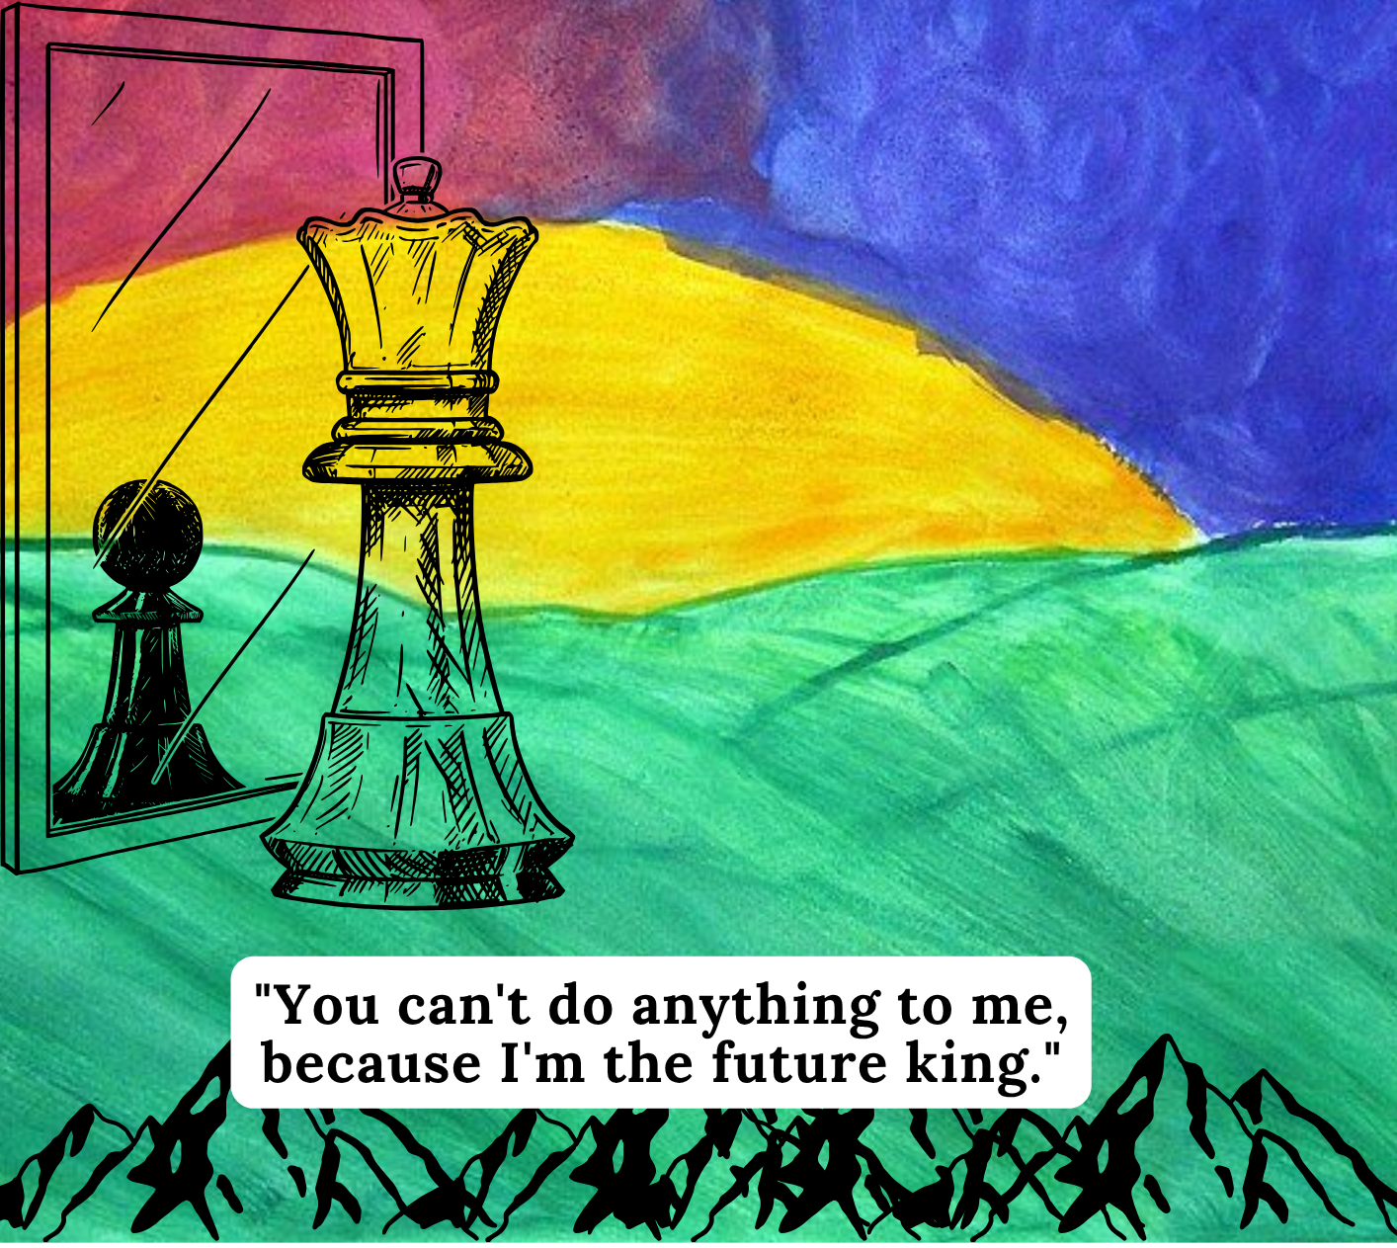Source: Vale of Glamorgan Council. Vale Youth Art Project 011. 2004, https://commons.wikimedia.org/wiki/File:Vale_Youth_Art_Project_011_(7204221960).jpg. Public domain. Edited with graphics from Canva Pro.

Paste a picture of your second artwork here:

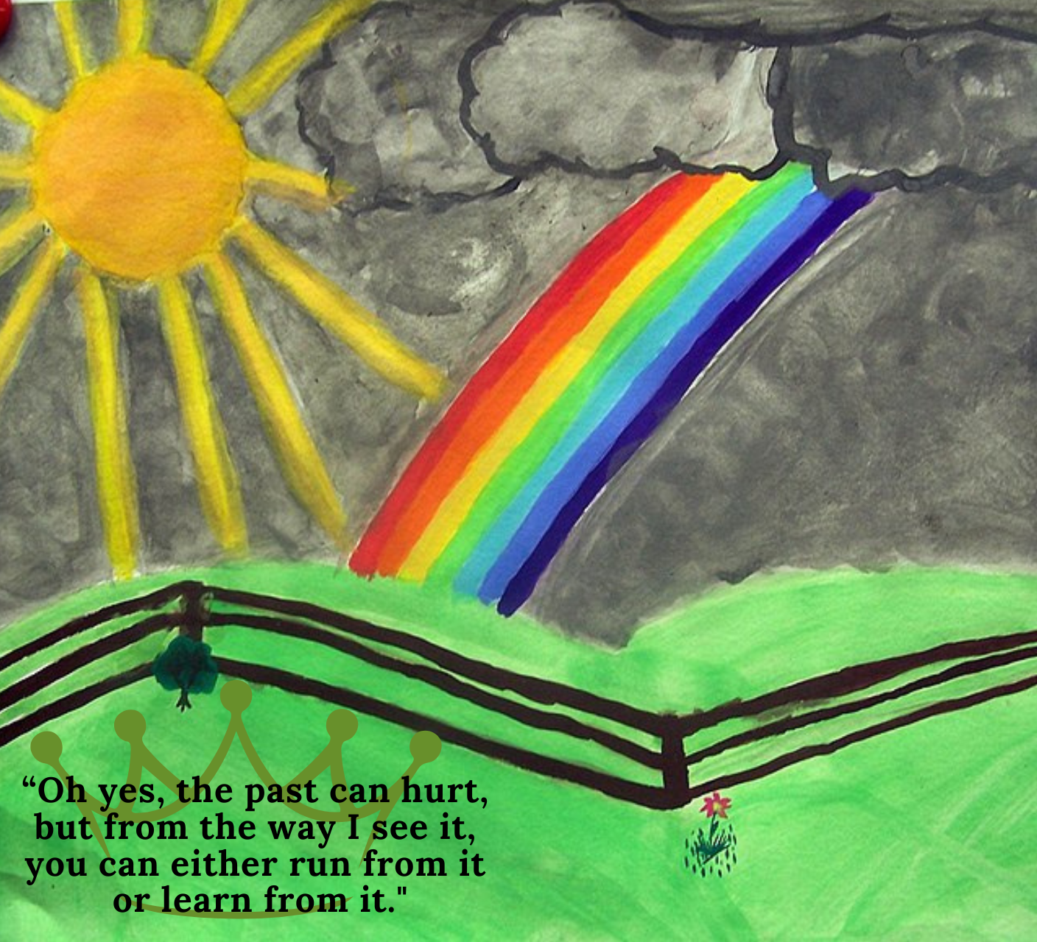
Source: Vale of Glamorgan Council. Vale Youth Art Project 016. 2004, https://commons.wikimedia.org/wiki/File:Vale_Youth_Art_Project_016_(7204220588).jpg. Public domain. Edited with graphics from Canva Pro.

Q1. Write a paragraph on what the character is like at the beginning of the story.
In your paragraph:
- Identify and explain at least two character traits the character shows at the beginning
- Include at least two examples or quotes in your paragraph to support your points.
Use these sentence starters:
At the beginning, the character shows traits such as _______ and _______
This is evident when the narrator/ playwright/ author/character says/writes “...”
This is shown in the scene when...
The character’s actions in this part of the story suggest that they feel/value…
A quote that reveals this is, “…”
At the beginning of the film, Simba is both naïve and arrogant. His naiveness is evident in his belief that when he becomes the king, he will get to do whatever he wants and have a free, fun life. For example, in the song “I Just Can’t Wait to Be King,” Simba sings about how he will be a “mighty king” who will be “free to run around all day” and do it all his way. It’s clear that Simba looks at being king as purely an adventure, without recognising the responsibilities in the position.
In addition, Simba is also arrogant, believing himself to be brave and immune to danger because he is a lion and the future king. This is shown in the scene when he goes into the elephant graveyard. When Zazu warns him they are beyond the boundaries of the Pride Lands, Simba tells him, “Danger? I laugh in the face of danger!” Immediately after this, the hyenas attack. This illustrates how Simba is immature and reckless because of his age, unable to recognise the value of being cautious and careful.
Q2. Write a paragraph on how the character has changed or developed by the end of the story.
In your paragraph:

- outline how the two traits mentioned in the first paragraph change by the end of the story.
- describe 1-2 big experiences the character goes through, and why it matters.
- comment on how the character feels, acts or thinks differently at the end vs. the beginning
Use these sentence starters:
Over the course of the story, the character gradually becomes more _______
One example of how the character has changed is when…
The character’s development is clearly shown when…
A moment that reveals the change in character’s personality is when…
This experience/event/moment is important because it shows the character has learned…
As the story continues, the character begins to think/feel differently about…(another character, place, event, etc)
By the end of the film, Simba has grown more courageous. One example of how the character has changed is when he decides to return to the kingdom and face his past, even though it will hurt. His decision to return home shows he has gained courage, and is willing to face the pain of returning to the kingdom and to his mother, even though he believes he is to blame for his father’s death.
In addition, Simba shows that he has grown more responsible and is ready to be king. This is evident when he is able to defeat Scar, finding the willpower to survive when his uncle almost throws him off the cliff at the end of the film. He forces his uncle to publicly admit, “I killed Mufasa!” loudly enough for all the other lions in the pride to hear. Then, he fights back and reclaims his kingdom. His climb up Pride Rock in the rain shows he is now much more mature and responsible, and will make a good king in the future.
Q3. In the organizer below, explain three choices you made in each artwork, and what these choices reveal about the chosen character.
Use these sentence starters:
In my artwork, I used _____[color] to show…
I chose to use a dark/light background because…
I included a tree/bridge/door [symbol] to represent…
I added sharp lines/curves/wavy lines to express…
I used cotton/cloth/cardboard [material] to create a soft texture that suggests…
I repeated the image/symbol/shape of ____ in two places to suggest…
I used bright/light/dark colors like _______to express…
I drew storm clouds/rain/sunshine [element] in the corner/top/center because…
This suggests that the character is feeling…
The use of this color reveals how the character is starting to learn…
This object or image connects to the moment when the character…
This shape or texture helps the audience understand that…

Artwork # 1
Artistic Choice (e.g., color, texture, shape, or symbol). | What this shows or represents about the character:
1. Visual symbol- king looking at the mirror and seeing a pawn in the reflection | I used the symbol of a chess piece king looking at the reflection of a pawn to represent how Simba is a pawn in Scar’s hands at the beginning of the film. Even though he believes he is going to be a “mighty king,” he is easily manipulated by Scar. His uncle makes him believe he is responsible for Mufasa’s death and convinces him to run away from his birthright as the future king. The mirror reveals his true reflection and represents how Simba doesn’t truly know himself.
2. The rising sun under a blood-red sky | I have used the rising sun to represent Simba’s hopeful and happy childhood. However, only half the sun has risen, showing he is young and not yet fully matured. The rising sun therefore connects well to Simba’s young age. The sky above the sun is blood-red, which illustrates the threat Simba is under from Scar.
3. Jagged mountains on a green field | I chose to place the jagged mountains at the bottom of the picture to symbolize the danger and obstacles Simba will have to face. Simba believes he can do whatever he wants when he is king, thinking his life will be smooth and full of fun, which is symbolized through the smooth green field. Simba does not yet recognize that to be a good king, he will first have to overcome challenges and suffering. The mountains on the green field show that while his life might be easy and smooth, he will have to overcome hardship in the future.

Artwork # 2
Artistic Choice (e.g., color, texture, shape, or symbol). | What this shows or represents about the character:
1. Bright sun in a dark, cloudy sky | I have used a bright, mid-day sun in the second image, which shines down on the land despite dark clouds. This represents Simba becoming the king after many years of hardship for both him and the kingdom. The rays of the sun touch the green earth, showing that healing and life has come to the land. It also reveals that Simba now has courage and maturity, is ready to take care of his land and people, and has learned how to be a good king.
2. Rainbow bridge | I have used a rainbow bridge from the dark clouds to the green grass to represent Simba’s journey. The bridge demonstrates how Simba is still connected to his past even after becoming king. The rainbow bridge connects back to the lessons of his father, whose spirit appeared in the clouds earlier in the film, reminding him of his responsibility. The bridge illustrates how Simba will stay connected to all his ancestors and will learn from past mistakes.
3. A light green crown | I placed the light green crown at the bottom of the page, surrounding the quote about learning from the pain of the past. I used a very light, subtle green to show that Simba is no longer ambitious or arrogant, and does not want to rule with a heavy hand. The green crown represents how he is the king of the savanna, connected to the grass, animals and plants. It illustrates how he is now a part of the “circle of life.”
Q4. Explain how the two quotes you chose connect to your artwork.
Use these sentence starters:
The quote in my first artwork is: “______” and it connects to the symbol/texture ______ because…
This quote helps me illustrate how the character is ______ at the beginning.
The quote in my second artwork is: “______” and I matched it with the color/symbol ______.
One artistic technique/element I used was ______ to reveal ______.
These examples and artistic tools help show the character’s mood, growth, and inner world.

The quote in my first artwork is “You can’t do anything to me, because I’m the future king,” which is a line from Simba to Zazu in the film. This connects to the characterisation of Simba as arrogant and naïve at the beginning of the film. It matches the symbol of the giant king chess piece looking at the reflection of a smaller pawn, because it captures the sense of Simba’s arrogance and inflated ego in the first part of the film, where he believes himself to be more powerful than he actually is.

The second artwork features the quote, “Oh yes, the past can hurt. But the way I see it, you can either run from it, or learn from it.” This line is spoken by Rafiki, and inspires Simba to return to the kingdom to face his past and reclaim his position as the king. I matched it with the symbol of the crown because it symbolizes the suffering he endured in order to mature enough to become worthy of ruling the Pride Lands.

Q5. Compare and contrast your two artworks:

In your response:

- describe 2-3 similarities in the artworks
- describe 2-3 differences in the artworks
- explain how the second artwork helps show the character’s growth/change

Use these sentence starters:
One thing that stayed the same in the two artworks is ______, because…
Another similarity is…
However, my first and second artworks are different in two main ways:
I used … in the first one, but …. in the second.
I showed the character’s personality as ______ first, but later as ______.
These differences/changes show the journey my character went through from ______ to ______.
If someone saw both artworks, they would understand that the character learned …

The two artworks I created have key similarities and differences which portray how the character changes over the course of the text. Firstly, both artworks feature an image of the sun over a bright green field. This symbolizes Simba’s position as the king of the Pride Lands. The bright sun depicts how the king is supposed to bring joy, brightness, and life to the other animals in the savanna. It portrays his optimistic and cheerful personality at the beginning and end of the story.

Another similarity is that both artworks portray clouds, which are used to represent dark times and suffering. The red clouds in the Artwork 1 suggest violence and death, partially covering and hiding the sun. This demonstrates the danger Simba is always in even early in the film when he is living a carefree life.

However, there are also key differences in the two texts. First, the black clouds in Artwork 2 are chased away by the sun, with the rays long enough to reach the earth. Moreover, unlike the Artwork 1, the sun is whole and round rather than half-hidden by the land. There is also a rainbow included in Artwork 2, which makes it a more colourful and bright landscape compared to Artwork 1.

Another difference is the inclusion of a black fence in Artwork 2 which divides the green land from the black clouds and rainbow. I included the fence in Artwork 2 because it shows how Simba’s position as a king acts as a barrier protecting his kingdom from darkness and death. On the green side of the barrier, a flower is growing, symbolizing life, growth and a thriving kingdom.

The changes in Artwork 2 show the journey Simba went through from being a naïve and arrogant young heir to an older, responsible king. It captures his journey from being someone easily manipulated to someone who defeats Scar and sees through his lies. Artwork 2 conveys to the audience that Simba will be a responsible and strong ruler, and can be trusted to protect and care for the other animals in the kingdom.

